6. fifo paging

Program:-

#include <stdio.h>

int main()

{

int referenceString[10], pageFaults = 0, m, n, s, pages, frames;

printf("\nEnter the number of Pages:\t");

scanf("%d", &pages);

printf("\nEnter reference string values:\n");

for( m = 0; m < pages; m++)

{

printf("Value No. [%d]:\t", m + 1);

scanf("%d", &referenceString[m]);

}

printf("\n What are the total number of frames:\t");

{

scanf("%d", &frames);

}

int temp[frames];

for(m = 0; m < frames; m++)

{

temp[m] = -1;

}

for(m = 0; m < pages; m++)

{

s = 0;

for(n = 0; n < frames; n++)

{

if(referenceString[m] == temp[n])

{

s++;

pageFaults--;

}

}

pageFaults++;

if((pageFaults <= frames) && (s == 0))

{

temp[m] = referenceString[m];

}

else if(s == 0)

{

temp[(pageFaults - 1) % frames] = referenceString[m];

}

printf("\n");

for(n = 0; n < frames; n++)

{

printf("%d\t", temp[n]);

}

}

printf("\nTotal Page Faults:\t%d\n", pageFaults);

return 0;

}

Output:-

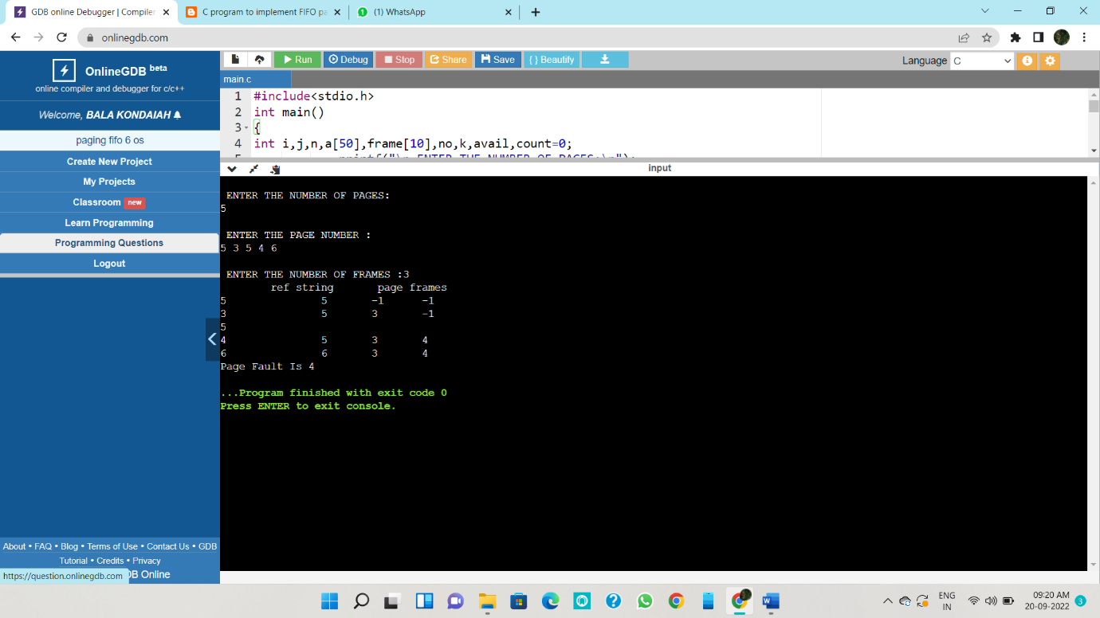

7. lru paging

Program:-

#include<stdio.h>

int findLRU(int time[], int n){

int i, minimum = time[0], pos = 0;

for(i = 1; i < n; ++i){

if(time[i] < minimum){

minimum = time[i];

pos = i;

}

}

return pos;

}

int main()

{

int no_of_frames, no_of_pages, frames[10], pages[30], counter = 0, time[10], flag1, flag2, i, j, pos, faults = 0;

printf("Enter number of frames: ");

scanf("%d", &no_of_frames);

printf("Enter number of pages: ");

scanf("%d", &no_of_pages);

printf("Enter reference string: ");

for(i = 0; i < no_of_pages; ++i){

scanf("%d", &pages[i]);

}

for(i = 0; i < no_of_frames; ++i){

frames[i] = -1;

}

for(i = 0; i < no_of_pages; ++i){

flag1 = flag2 = 0;

for(j = 0; j < no_of_frames; ++j){

if(frames[j] == pages[i]){

counter++;

time[j] = counter;

flag1 = flag2 = 1;

break;

}

}

if(flag1 == 0){

for(j = 0; j < no_of_frames; ++j){

if(frames[j] == -1){

counter++;

faults++;

frames[j] = pages[i];

time[j] = counter;

flag2 = 1;

break;

}

}

}

if(flag2 == 0){

pos = findLRU(time, no_of_frames);

counter++;

faults++;

frames[pos] = pages[i];

time[pos] = counter;

}

printf("\n");

for(j = 0; j < no_of_frames; ++j){

printf("%d\t", frames[j]);

}

}

printf("\n\nTotal Page Faults = %d", faults);

return 0;

}

Output:-

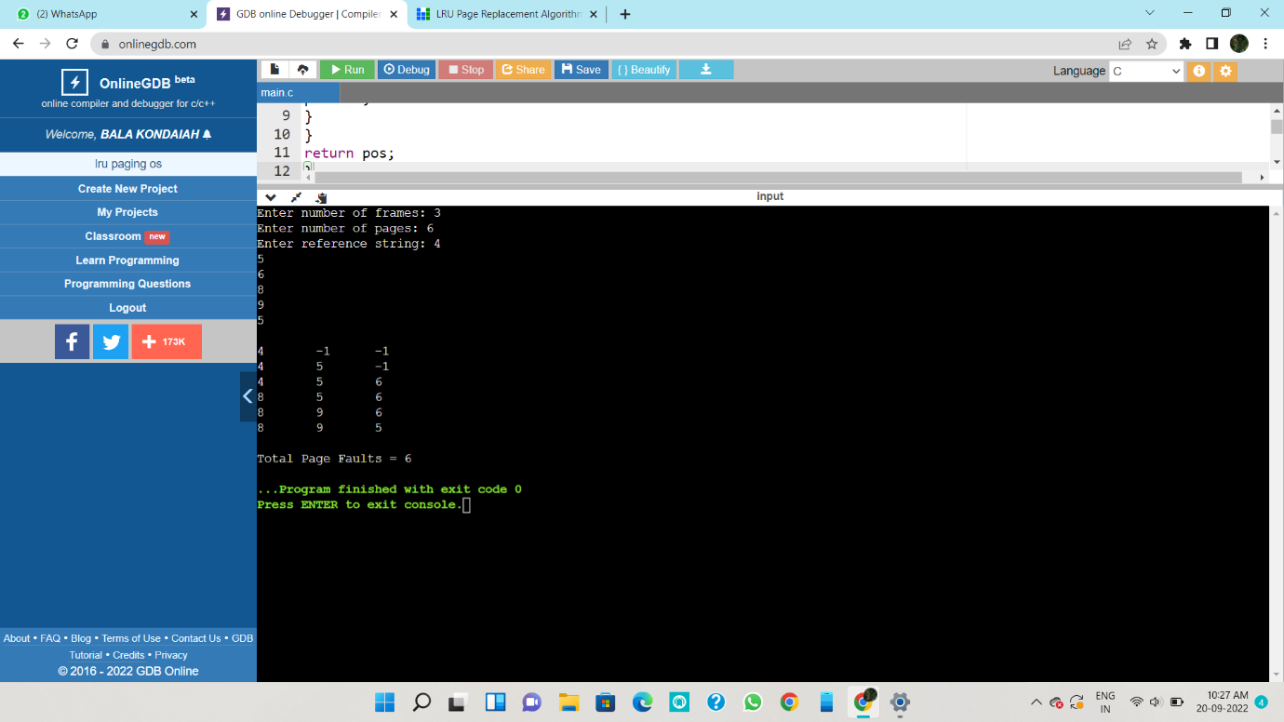

8. optimal paging

Program:-

#include<stdio.h>

int main()

{

int no_of_frames, no_of_pages, frames[10], pages[30], temp[10], flag1, flag2, flag3, i, j, k, pos, max, faults = 0;

printf("Enter number of frames: ");

scanf("%d", &no_of_frames);

printf("Enter number of pages: ");

scanf("%d", &no_of_pages);

printf("Enter page reference string: ");

for(i = 0; i < no_of_pages; ++i){

scanf("%d", &pages[i]);

}

for(i = 0; i < no_of_frames; ++i){

frames[i] = -1;

}

for(i = 0; i < no_of_pages; ++i){

flag1 = flag2 = 0;

for(j = 0; j < no_of_frames; ++j){

if(frames[j] == pages[i]){

flag1 = flag2 = 1;

break;

}

}

if(flag1 == 0){

for(j = 0; j < no_of_frames; ++j){

if(frames[j] == -1){

faults++;

frames[j] = pages[i];

flag2 = 1;

break;

}

}

}

if(flag2 == 0){

flag3 =0;

for(j = 0; j < no_of_frames; ++j){

temp[j] = -1;

for(k = i + 1; k < no_of_pages; ++k){

if(frames[j] == pages[k]){

temp[j] = k;

break;

}

}

}

for(j = 0; j < no_of_frames; ++j){

if(temp[j] == -1){

pos = j;

flag3 = 1;

break;

}

}

if(flag3 ==0){

max = temp[0];

pos = 0;

for(j = 1; j < no_of_frames; ++j){

if(temp[j] > max){

max = temp[j];

pos = j;

}

}

}

frames[pos] = pages[i];

faults++;

}

printf("\n");

for(j = 0; j < no_of_frames; ++j){

printf("%d\t", frames[j]);

}

}

printf("\n\nTotal Page Faults = %d", faults);

return 0;

}

Output:-

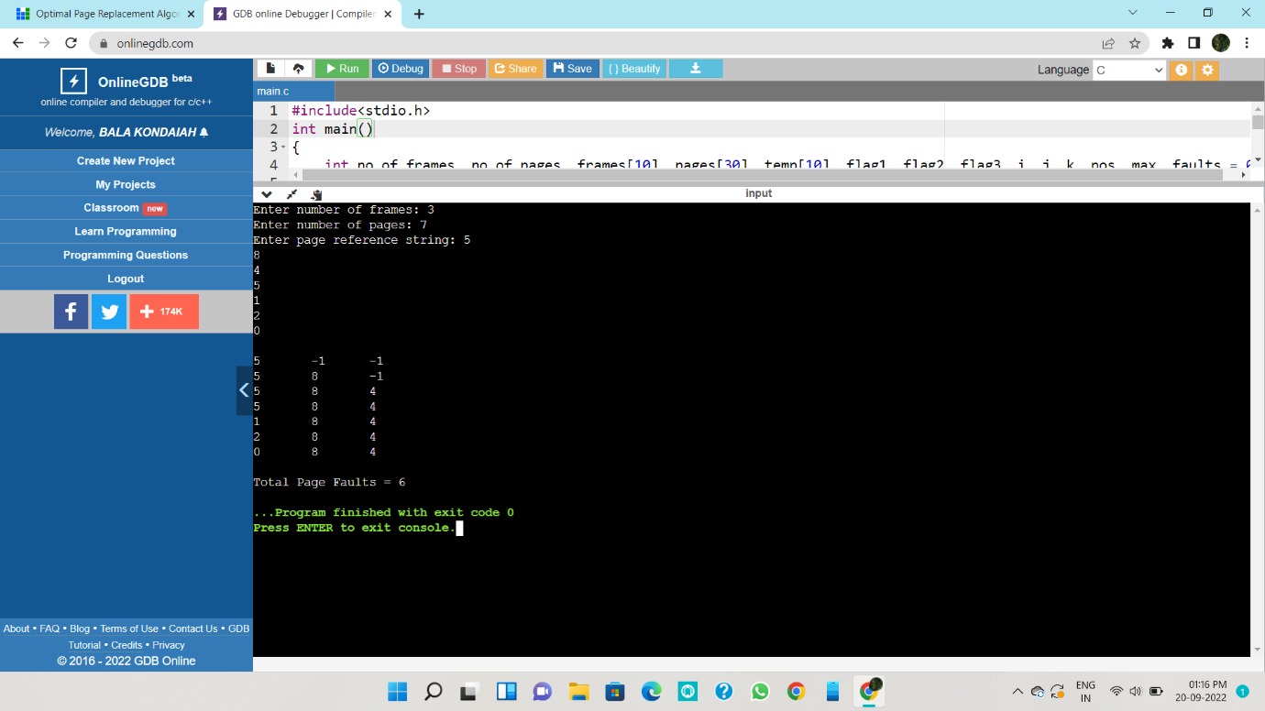

9. sequential file allocation

Program:-

#include <stdio.h>

#include <conio.h>

#include <stdlib.h>

void recurse(int files[]){

int flag = 0, startBlock, len, j, k, ch;

printf("Enter the starting block and the length of the files: ");

scanf("%d%d", &startBlock, &len);

for (j=startBlock; j<(startBlock+len); j++){

if (files[j] == 0)

flag++;

}

if(len == flag){

for (int k=startBlock; k<(startBlock+len); k++){

if (files[k] == 0){

files[k] = 1;

printf("%d\t%d\n", k, files[k]);

}

}

if (k != (startBlock+len-1))

printf("The file is allocated to the disk\n");

}

else

printf("The file is not allocated to the disk\n");

printf("Do you want to enter more files?\n");

printf("Press 1 for YES, 0 for NO: ");

scanf("%d", &ch);

if (ch == 1)

recurse(files);

else

exit(0);

return;

}

int main()

{

int files[50];

for(int i=0;i<50;i++)

files[i]=0;

printf("Files Allocated are :\n");

recurse(files);

getch();

return 0;

}

Output:-

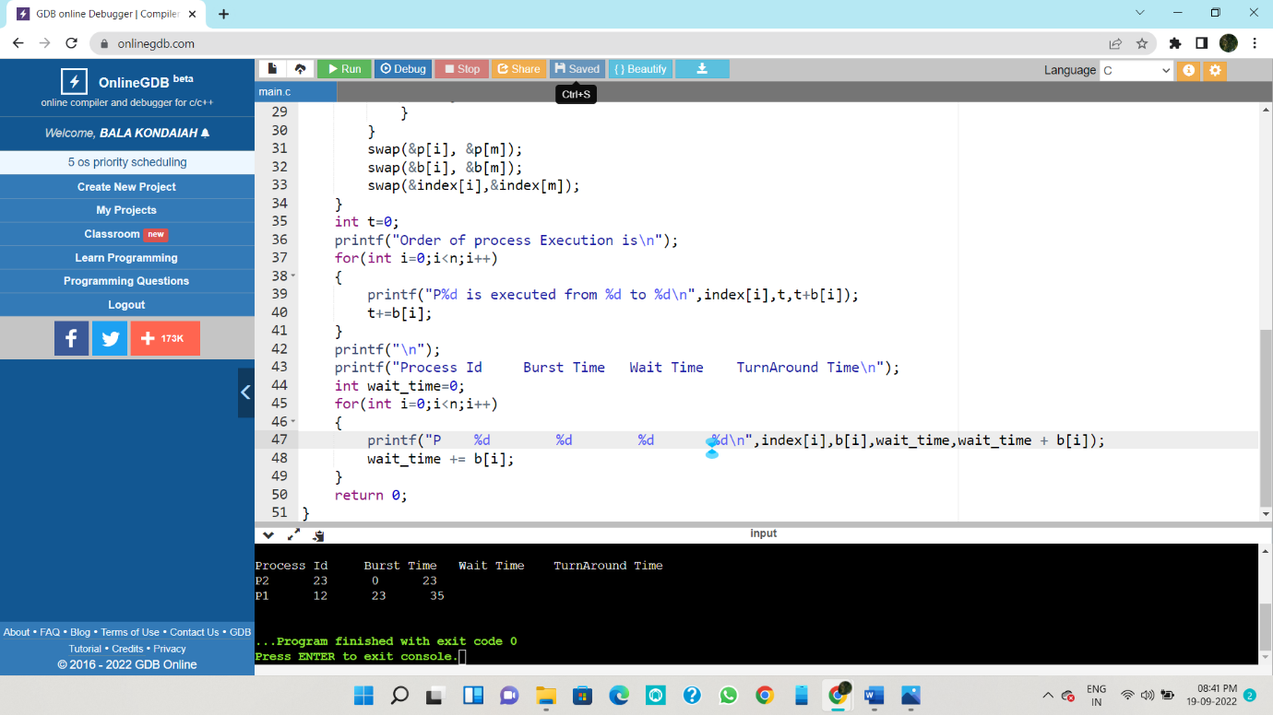

10.Producer consumer problem

Program:-

#include<stdio.h>

#include<stdlib.h>

int mutex=1,full=0,empty=3,x=0;

int main()

{

int n;

void producer();

void consumer();

int wait(int);

int signal(int);

printf("\n1.Producer\n2.Consumer\n3.Exit");

while(1)

{

printf("\nEnter your choice:");

scanf("%d",&n);

switch(n)

{

case 1: if((mutex==1)&&(empty!=0))

producer();

else

printf("Buffer is full!!");

break;

case 2: if((mutex==1)&&(full!=0))

consumer();

else

printf("Buffer is empty!!");

break;

case 3:

exit(0);

break;

}

}

return 0;

}

int wait(int s)

{

return (--s);

}

int signal(int s)

{

return(++s);

}

void producer()

{

mutex=wait(mutex);

full=signal(full);

empty=wait(empty);

x++;

printf("\nProducer produces the item %d",x);

mutex=signal(mutex);

}

void consumer()

{

mutex=wait(mutex);

full=wait(full);

empty=signal(empty);

printf("\nConsumer consumes item %d",x);

x--;

mutex=signal(mutex);

}

Output:-

